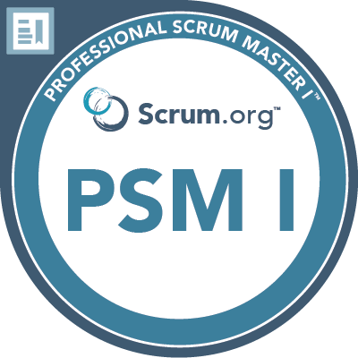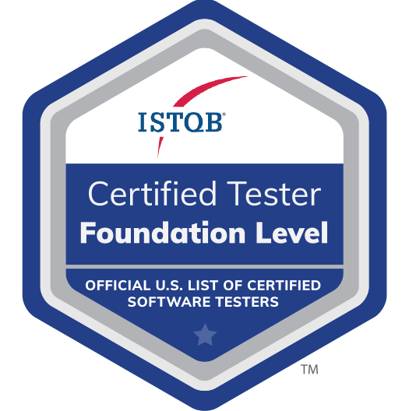

**Hemalatha**

**Ph#: 443-961-2005**

**Visa: H4 EAD**

**Professional Summary:**

* Over **7 years** of experience in Information Technology, specializing in Software **Quality Assurance Testing**, proficient in testing on **Client/Server** and **Web based applications.**
* Strong exposure in **Software Development Life Cycle (SDLC)** methodologies.
* Extensive experience in Quality Assurance, Manual functional testing , complete end-to-end module testing involving various modules.
* Expert in automation testing using **Selenium WebDriver, Cucumber and Maven framework**
* Strong working knowledge of programming using **Java and TestNG**.
* Conversant with **Maven** project build tools**.**
* Proficient in **Power BI, SSIS, SSRS and HTML reports.**
* Experience in **Continuous Integration/ Continuous Delivery (CI/CD)** using Jenkins integrated with GitHub.
* Experience includes Functional testing, User Acceptance Testing, System testing, Performance testing, Exception testing, Compatibility testing and Security testing of client/server and Web based Applications.
* Experience in designing **Test Cases, Test Scenarios, Test Scripts** and **Test reports** of manual and automated tests
* Proficient **in black box testing,** performance testing, Graphical User Interface testing (GUI), User Acceptance Testing (UAT), **Regression Testing, Integration Testing and white box testing.**
* Experience in defining Testing Methodologies, writing and executing test cases, Designing Test Plans, Test Documentation and creating traceability matrix as well as working with test data.
* Experience in providing the efficient locators strategy like **XPath and CSS to run WebDriver script** in stable condition.
* Experience with testing web services using **SOAP UI/POSTMAN** and **XML.**
* Undergone Training **on BDD using cucumber and Appium for Mobile Automation Testing.**
* Excellent interpersonal and communication skills. Good documentation and process management skills with ability to effectively understand the business requirement to develop a quality product.
* Ability to adapt to new environments quickly, strong team player, good communication, good analytical and computation skills, enthusiastic learner, confident, sincere and committed.

**Certifications**

* + ISTQB Certified Tester Foundation Level

<https://atsqa.org/certified-testers/profile/ec7829e444724c43924b4962713f40a3>

* + Professional Scrum Master I <https://www.credly.com/users/hemalatha-thulasi/badges>
  + Microsoft certified power BI -Data Analyst Associate

<https://learn.microsoft.com/en-us/users/hemalathathulasi-4440/credentials/a7c7f3143c51ea59>

**Technical Skills:**

|  |  |
| --- | --- |
| **Testing Tools** | Selenium WebDriver/IDE/GRID, TestNG, Jenkins, Cucumber, Soap UI, Postman. |
| **Web Technologies** | HTML, XML, CSS |
| **Defect Tracking Tools** | HP ALM, Quality Center, JIRA |
| **Build Tools** | MAVEN |
| **Languages** | Java, SQL |
| **SDLC Methodologies** | Agile, SCRUM, Waterfall |
| **Database** | Oracle, MS SQL Server, SQL |
| **Operating Systems** | Windows , UNIX and Linux |

**Professional Experience:**

**Client: BMO Harris Bank, Chicago, IL. Jun 2022 – Till Date**

**Role: Test Automation Engineer (QA) Responsibilities:**

* Reviewed **business requirements and technical specification** documents and Analyzed **use cases, functional requirements** to write detailed **Test plans and Test cases**.
* Developed and executed test cases and automation regression testing using **Selenium WebDriver.**
* Used **Selenium WebDriver** APIs for writing **TestNG** test suites and test cases for testing functionality.
* Developed Behavior Driven Development (BDD) scripts with Cucumber using Maven framework by writing behaviors and step definitions
* Used Github repository for version control on all automation scripts, documents and artifacts.
* Leveraged **Continuous Integration/Continuous Delivery** pipeline using **Jenkins with Github repository for automatic deployment of test scripts** and running **automated functional** tests.
* Developed Mobile Automation scripts (IOS and Android) using **Selenium WebDriver** - for responsive web designing and cross browser validation using **Appium and UI Automator.**
* Developed Test Framework in **Protractor** for UI Regression Test Automation and implemented testing framework in Jenkins for continuous integration.
* Used **Selenium GRID** to execute test cases parallel on different target machines.
* Worked actively with developers in expediting the code as against the specs and performing **Unit Testing**.
* Converted all Record and play back **Selenese** test cases into Selenium automated scripts.
* Authored and Executed **Automation** and **Manual** Test Cases for **Functional testing** of various modules of the application.
* Involved in providing the efficient locators strategy like **XPath, modified XPath** and **CSS** to run **WebDriver** script in stable condition.
* Closely worked with developers and product owners in an **Agile Environment** using technical stories to create automated **APIs (REST/SOAP)** and built a framework for continuous support for future releases.
* Executed **SOAP** based web services **API testing** (**Java client** and **Postman**).
* Used **HP ALM** for Test Management, for Functional Test Automation.
* Planned and executed Backend testing using numerous **SQL Queries** to verify the dataflow from the database.
* Provided all data validation through **SQL Queries UNIX** commands to perform **Back-end Testing.**
* Coordinated with upper management daily regarding status on the execution of Test Cases (**How many Test Cases failed/pass, status of the site**).

**Client: Banner Health, Phoenix, AZ. Apr 2021 – May 2022**

**Role: Automation Engineer (QA) Responsibilities:**

* Implemented automation with Selenium WebDriver, Selenium Grid and TestNG using Java.
* Extensively automated regression and functional test suites using Selenium WebDriver, JAVA, and TestNG.
* Used Selenium Grid to execute Selenium automation suites on different platform, browser combinations in parallel.
* Developed BDD tests using Cucumber by writing behaviors and step definitions. Developed required Selenium support code in JAVA for Cucumber.
* Created data-driven automation scripts for testing **API Web Services** using **Postman.**
* Involved in QA Testing (**UI** and **API**), and collaborating with off-shore QA personnel on current projects and documenting and reporting defects and test results in **Quality Center**.
* Used **TestNG** to prioritize the scripts and run in batches and extract test reports.
* Responsible for creating the functional testing framework using **TestNG** and using **Selenium WebDriver** to automate the **UI** components.
* Involved in Grouping of Test Cases, Test Methods, and Test Suites using **Test-NG** annotations.
* Involved in preparing a report of all automation difficulties and test results for further application using **Maven.**
* Responsible for writing **Gherkin** and **Java** scripting automation scripts to execute in **Cucumber.**
* Involved in setting up **continuous integration** using **Jenkins** and working knowledge with cloud based repositories like **GitHub.**
* Create and maintain regression scripts for automated testing utilizing **Appium and Java.**
* Performed Defect Tracking & Management in JIRA.
* Worked in a highly dynamic AGILE environment and participated in scrum and sprint meetings
* Saved 30% time and cost of testing by automation using Selenium WebDriver, Java.
* Achieved customer satisfaction and high quality by effective Automation testing.

**Client: Home Away Inc., Austin, TX. Dec 2019 – Mar 2021**

**Role: QA Analyst Responsibilities:**

* Built efficient SQL scripts, indexes, complex queries for cyber data analysis and extraction and performed ETL tasks to run services through web channels
* Involvement in Requirement Analysis and Requirement Elaboration Sessions
* Responsible across areas like requirement definition, execution and evaluation of functional tests, review, test governance, Test
* Results analysis and Defect Reviews
* Responsible for providing Business Acceptance Test Estimates, Overall Project Schedule, providing status updates, developing communication Plan for the Project
* Coordination across business units affecting the project
* Conducted review sessions with the various stakeholders on the Business Acceptance Test artifacts
* Took up the initiative as a scrum master, performed all the scrum ceremonies and supported short and long-term release planning,kept the work backlog health, and prepared for execution

**Client: LPL Financial, San Diego, CA. Apr 2017 – Nov 2019**

**Role: QA Analyst Responsibilities:**

* Understanding the business requirements and scope of application
* Designed effective test scenarios, boundary conditions & optimized test cases
* Requirement management in Quality center
* Created Test scripts for the provided Test Scenarios
* Performed Test script review and uploaded to Quality center from Excel and test script execution in testing environment and in QC
* Performed Requirement mapping with Test conditions in Test plan in QC
* Performed mapping between Tests in Test plan with respective Test sets in Test lab modules in QC
* Defect Management like defect raising and follow up with respective team, defect retesting and closing the same with tested screenshots
* Created Test Data Characteristics, Test plan & Test Approach.