Tejaswini Singirikonda  mobile: +1(479)-321-4604  Email: steja.0413@gmail.com  Senior DevOps Engineer | 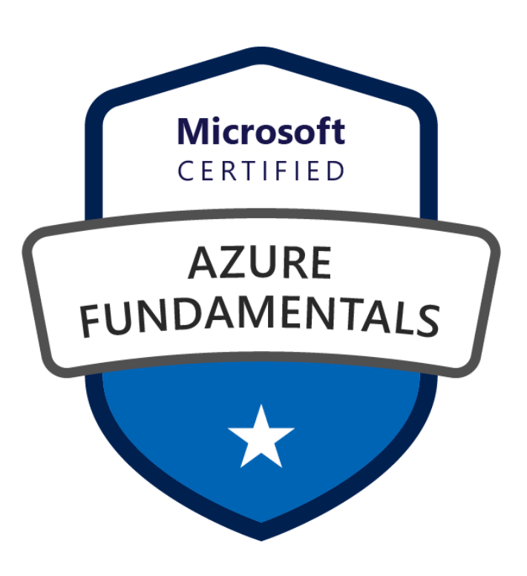 | 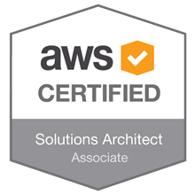
PROFILE SUMMARY
- Around 13 years of experience in IT sector build engineering and release management process, building and deploying applications by adopting DevOps practices such as Continuous Integration (CI) and Continuous Deployment (CD)in runtime with various tools like GitHub, Jenkins, Ansible, Terraform, Docker, Kubernetes and managing cloud services with Azure, GCP, AWS & WCNP.
- Proficient in defining Build Pipelines in addition to creating and maintaining multiple jobs. Extensively worked on Jenkins, GitHub Actions, Gitlab, Cloud Build/Cloud Deploy and ADO for Continuous Integration and End-to-End automation for all builds and deployments across VM’s, AWS, Azure and GCP.
- Good knowledge of packaging tool Helm for deploying applications in Kubernetes clusters. Responsible for writing manifest files in helm for deploying applications.
- Extensive experience in working with Docker images/ containers in containerizing applications as well as deployment and management of complex run time environment like Kubernetes.
- Strong expertise in Infrastructure as Code using Terraform and Ansible, building reusable modules, automating provisioning, and enforcing compliance across multi-cloud and on-premises environments, significantly improving deployment speed and reliability.
- Extensive hands-on experience implementing and managing observability platforms including Dynatrace, Prometheus, CloudWatch, Splunk, New Relic and Grafana to deliver end-to-end monitoring, real-time alerting, and automated root-cause analysis across cloud-native and Kubernetes environments, significantly improving system reliability and reducing MTTR.
- Proficient in Python scripting for automation, CI/CD pipeline development, and infrastructure orchestration, with hands-on experience building tools to streamline deployments, monitoring, and security integrations.
- Hands-on SRE with strong expertise in cloud-native reliability engineering, incident management, observability, and automation using Terraform, Kubernetes, and Python.
- Implemented HashiCorp Terraform and Vault for multi-cloud automation and secrets management, enabling secure, consistent, and scalable deployments across AWS, Azure, and GCP.
- Extensive experience embedding security into DevOps workflows, implementing role-based access control (RBAC), TLS encryption, centralized secrets management (Vault, Key Vault, AWS Secrets Manager).
ACADEMIC DETAILS
- Bachelor Of Technology in Information Technology, JNTU
CERTIFICATIONS & ACHIEVEMENTS
- Certified as Dale Carnegie
- Microsoft Certified: Azure Fundamentals
- AWS Certified Solutions Architect-Associate
- OneOps In-house Certification
- WCNP (Walmart could native platform) In-house Certification
- Walmart Associate of the Month (March 2020)
LINKEDIN PROFILE
https://www.linkedin.com/in/tejaswini139004

Work Authorization
Green Card (No sponsorship required)
IT SKILLS
- Cloud Platforms: WCNP, Google Cloud Platform (GCP), Microsoft Azure, AWS
- Operating Systems: Linux, UNIX, Windows, Mac OS
- Virtualization: VMware Workstation, Vagrant
- Version Control & Collaboration: Git, GitOps, Bitbucket, SVN, TFS
- Artifact Management: Nexus, Artifactory, Proximity
- Issue/Bug Tracking: Jira, ServiceNow, Remedy
- CI/CD Pipelines: Jenkins, GitLab CI, GitHub Actions, Azure DevOps (ADO), Cloud Build, Harness, Circle CI, TFS, Concord, Looper, Atomic
- Infrastructure as Code / Config Management: Terraform, Ansible
- Containers & Orchestration: Docker, Kubernetes, Kustomize Kubernetes
- Monitoring & Logging: Prometheus, New Relic, Grafana, Dynatrace, Splunk, Nagios, Azure Monitor, Google Cloud Operations
- Web & Application Servers: Nginx, Apache Tomcat, Apache HTTP Server, Jetty
- Programming / Scripting: Python, Shell, JavaScript, PowerShell
- Databases / Data Platforms: MySQL, SQL Server, Informix, Snowflake
PROFESSIONAL EXPERIENCE
Senior DevOps Engineer
General Motors
Austin, TX
May 2022 to Present
Responsibilities:
- Engineered end-to-end serverless workflows using Azure Logic Apps and Function Apps, integrating with CI/CD pipelines to automate deployments, streamline business processes, and ensure high availability, scalability, and fault-tolerant execution across multi-environment Azure workloads.
- Worked on Fortify Scan and Black Duck Scan and incorporated with in the Azure DevOps pipeline to check the vulnerabilities of source code.
- Implemented azure monitoring set up on resource group level using log signals and writing quires on azure activity.
- Created PBI dashboard to monitor incidents, changes, and security compliance at organization level.
- Developed Python-based automation tools to integrate observability, security scans, and deployment validation into CI/CD pipelines, reducing manual effort by 40%.
- Created Azure pipelines and templates in Azure DevOps to build and deploy on AKS.
- Worked on functional testing for function apps (HEMS) and logic apps (FLEET/OVI) projects which are running on azure.
- POC on azure bicep for developing ARM templates.
- Researched and created Logic app to communicate the messages from IBM MQ to Logic app and vice versa.
- Integrated JavaScript scripts into Jenkins/GitLab pipelines for automating build verification, release readiness checks, and artifact management.
- Implemented CI/CD pipelines using GitHub Actions to automate build, test, security scan, and deployment workflows.
- Integrated Terraform with GitHub Actions/ADO to perform automated infrastructure provisioning on PR merge to staging/production environments.
- Implemented network monitoring and root cause analysis using IP SLA and event correlation, improving uptime and reducing troubleshooting time.
- Implemented Harness Connectors to integrate with GitHub, Docker registry, Kubernetes clusters, and cloud providers.
- Created Lambda Function to send notification via SNS when there is an IMPAIRED Volumes for production EC2 Instances.
- Researched and implemented Kustomize Kubernetes to easily manage various environments and perform deployments.
- Worked on Automation to Scale Up Environments, Nodes and HPA to support performance testing.
- Managing the AWS Secrets, updating the deployment files accordingly and performing the micro services deployment to pull the latest secrets.
- Worked on creating new environments, performing the deployments, and supporting the performance testing.
- Secured serverless workloads (AWS Lambda, Azure Functions) by enforcing least-privilege IAM roles, integrating with AWS Secrets Manager & Azure Key Vault, and implementing runtime monitoring.
- Worked on resolving the security findings from the security hub for the EC2 instances.
- Performing EKS upgrades for EKS worker nodes and New Relic infrastructure agent
- Created and documented New Relic Dashboards, Errors Inbox and workflows for all the environments.
- Researched and implemented on optimal HPA setting for EKS Clusters.
- Deployed containerized applications to EKS using Helm and automated updates via GitHub Actions with image tag promotion.
- Built reusable Terraform modules for networking, IAM roles, ECR repositories, and EKS clusters, shared across multiple projects.
- Designed and managed VPCs, subnets, security groups, and load balancers across AWS and Azure to ensure secure, scalable connectivity for microservices.
Environment: GIT HUB, GitHub Actions, AWS, Terraform, S3, IAM, EC2, Lambda, EKS, Event Hub, MAVEN, NPM, Azure pipelines, ADO, Azure Monitoring, Logic apps, Func apps, ARM templates, PBI, ARM templates, Snowflake, SQL, Shell Scripting, JavaScript, JIRA, Docker, Kubernetes, Kustomize Kubernetes, Python, YAML.

Software Engineer 3 Tech (Senior DevOps)
WALMART
Bentonville, AR
Jun 2016 to April 2022
Responsibilities:
- Worked on migrating MS SQL Database to Azure SQL Database
- Developed a CI/CD roadmap and created Concord templates for various deployment types for NextGen applications, resulting in faster deployment cycles and improved consistency across environments.
- Built custom Python scripts to connect with Prometheus and Grafana APIs, automatically generating observability dashboards and alert rules for new services
- Migrated all Atlas services from on premises to Walmart Cloud Native Platform and on boarded MS and OneOps applications to Dynatrace without having any down time.
- Implemented and automated Post validation process for GLS legacy application.
- Developed JavaScript-based automation scripts to streamline CI/CD tasks such as log parsing, API integrations, and deployment validations.
- Worked on reducing the build time and managed release schedules, versioning and change control process for GLS legacy applications.
- Created flip tool using JavaScript to merge the code from GIT HUB development branch to master branch by one click.
- Created and managed Jenkins pipelines for Kubernetes deployment and responsible for maintaining applications in Kubernetes clusters.
- Enabled secure interconnectivity between GKE workloads and GCVE VMs using VPC peering, Cloud NAT, and Terraform-managed IAM policies.
- Developed enterprise CI/CD pipelines on GCP (Cloud Build, Artifact Registry, Cloud Deploy) to standardize release processes and accelerate developer productivity.
- Migrated critical workloads from on-prem to GCP, modernizing with GKE, Cloud Run, and Pub/Sub, reduced operational overhead by 30% through container orchestration and autoscaling.
- Implemented GitOps-style deployments to GKE using Helm and GitHub Actions, automating image updates, health checks and canary deployments.
- Worked on designing and execution of Zero down-time and Canary deployments in various regions in cloud platforms.
- Created alerts and monitoring dashboards using Prometheus & Grafana for all services running on WCNP.
- Configured Dynatrace dashboards, alerts, and anomaly detection to provide real-time visibility into performance bottlenecks.
- Configured Ingress controllers, DNS, and TLS certificates to support multi-domain applications on Kubernetes clusters.
- Integrated Database changes with CICD pipeline to be deployed along with the application changes and implemented Liquibase Rollback in the CICD workflows
- Created self-serve tools for developers like restarting the k8s pods without any downtime, restarting load balancer ports, scaling deployment on k8s, deleting the failed deployments on edge.
- Responsible for Onboarding JET.COM applications on Kubernetes.
- Worked on publishing k8s, VM and DB deployment metrics to Hygeia dashboard.
- Developed Ansible playbooks for the deployment process, which deploys to VM’s, K8s and Database schema.
Environment: GitHub, Bit Bucket, Maven, Nexus, Proximity, looper, Target Management, Config Management, Jenkins, Ansible, Docker, Concord, Kubernetes, GKE, Cloud build, GCVE, Pub/Sub, Google CSR, Prometheus, Splunk, Medusa, Dynatrace, Kibana, Grafana, Nagios, Apache httpd, Apache tomcat, Subversion, Git Hub, Jenkins, MAVEN, NPM, Shell Scripts, Java Script, YAML, UNIX, LINUX, JIRA, Looper, Python, Atomic, Azure, Managed Servlet, Dynatrace, WCNP, Torbit.

Build and Release Engineer
Wolters Kluwer
New York City
Sep 2015 to Jun 2016.
Responsibilities:
- Build Release Engineer for 8 project teams that involved different development teams and multiple simultaneous software releases.
- Participated in weekly release meetings with Technology stakeholders to identify and mitigate potential risks associated with the releases.
- Developed build and deployment scripts using ANT and MAVEN as build tools in Jenkins to move from one environment to other environments.
- Implemented continuous integration with Team City for advance notice of broken builds, failing unit tests and duplicated code.
Environment: Subversion (SVN), Jenkins, Java/J2EE, ANT, MAVEN, Web Logic, Perl Scripts, Shell Scripts, XML, UNIX, JIRA, Team city, OpenStack.

Build & Release Engineer
Model N Technologies
Hyderabad, India
Sep 2011 to Dec 2014
Responsibilities:
- Sending the Uptime and Downtime notifications to teams regarding Servers Status as a part of the Build Engineer role at the time of deploying the EAR and WAR package in Tomcat Admin Console.
- Regular Build jobs are initiated using the Continuous Integration tool like Jenkins.
- Publishing the Release notes for all the releases.
- Converted and automated builds using Maven and Ant. Scheduled automated nightly builds using Jenkins.
Environment: Jenkins, GIT, SVN, ANT, MAVEN, JIRA, JAVA/J2EE, Web Sphere, Nexus.

